

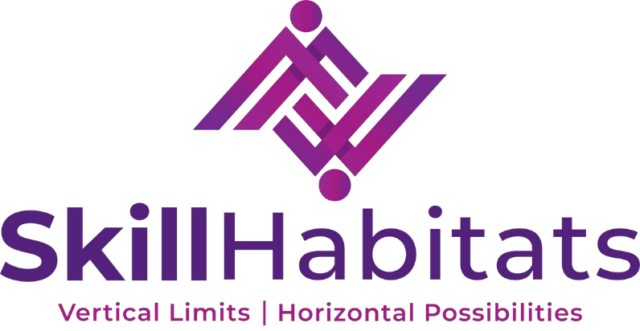

INTERNSHIP
IN
FULL-STACK DEVELOPMENT
CONDUCTED BY
SKILL HABITATS
W-115, 1st Floor, 3rd Avenue, Anna Nagar, Chennai– 600004

FULL-STACK DEVELOPMENT
Submitted by
VENGADESAN G
Register Number: 311821205060
in partial fulfillment for the award of the degree of
BACHELOR OF TECHNOLOGY
In
INFORMATION TECHNOLOGY
MOHAMED SATHAK A.J. COLLEGE OF ENGINEERING,
CHENNAI

ANNA UNIVERSITY: CHENNAI 600 025
JUNE 2025

Abstract
This report documents the internship experience of Vengadesan G, undertaken at Skill Habitats, Chennai, from 1st December 2024 to 31st May 2025, as part of a real-time software development project. The internship involved contributing to the development of PlaceNow, a full-stack web-based hiring platform designed to simplify and digitize the recruitment process for companies and job seekers. This initiative aimed to create an efficient, user-friendly, and scalable solution to support end-to-end hiring operations.
Over the six-month internship period, I was actively involved in various stages of software development, including front-end interface design using HTML, CSS, and JavaScript, and back-end technology Django, and database management using MySQL. My key responsibilities included building responsive web pages, implementing form validations, integrating dynamic content with database queries, and ensuring smooth user interactions across different modules of the platform. Additionally, I gained hands-on experience in creating candidate registration systems, job posting features for recruiters, and secure login functionalities for multiple user types.
As the platform targeted real-time deployment and client usability, the project also emphasized performance optimization, UI consistency, and secure data handling practices. I collaborated with developers and mentors from Skill Habitats to follow structured development workflows and version control. During the project lifecycle, I developed critical skills in full-stack development, system architecture planning, and agile project management.
The internship served as a significant learning curve by blending academic knowledge with practical exposure in a corporate tech environment. Working on PlaceNow allowed me to understand the challenges of designing scalable hiring systems and sharpened my expertise in both frontend and backend technologies. The experience has not only enhanced my technical capabilities but also strengthened my problem-solving and collaborative skills, which will be invaluable in my future endeavors as a software developer.

Table of Contents
Title Page
- Abstract
- Briefing about the industry
- Introduction to Technology and Domain
- Weekly Work Done
- Flowcharts
- Sample Outputs
- Internship Offer Letter
- Internship Certificate
- Outcome of The Training

Briefing About the Industry

SkillHabitats Workforce Solutions Private Limited, founded in December 2022, is a fast-growing HR consulting and outsourcing company based in India. The company provides end-to-end workforce solutions that help businesses streamline operations by managing their non-core tasks efficiently. SkillHabitats offers services such as recruitment, staffing, training and development, facility management, logistics, last-mile delivery, and HR consulting tailored to various industries.
Operating across diverse sectors including manufacturing, e-commerce, retail, IT, and customer support, SkillHabitats leverages flexible workforce models—onsite, offsite, hybrid, and remote—to meet the unique needs of its clients. Their solutions are delivered through structured Service Level Agreements (SLAs), job work models, and turnkey projects, ensuring accountability, scalability, and consistent quality.
A key strength of SkillHabitats lies in its use of future-ready digital platforms that enhance operational efficiency, workforce tracking, and real-time business insights. This tech-driven approach enables them to meet the evolving demands of modern businesses while maintaining cost-efficiency and agility in execution. The company’s integrated approach allows clients to focus on their core business while SkillHabitats handles essential support functions.
At its core, SkillHabitats promotes a people-centric culture. The company values professionalism, honesty, and ethical practices in every interaction. With a strong focus on client satisfaction, operational excellence, and long-term partnerships, SkillHabitats has quickly become a trusted partner in India’s workforce and business outsourcing ecosystem.
As the Indian business landscape continues to evolve rapidly, the demand for flexible and scalable workforce solutions is growing. SkillHabitats is committed to continuously expanding its service offerings and technological capabilities to stay ahead of market trends. Its commitment to innovation, combined with strong domain expertise, positions the company well to support businesses of all sizes in achieving operational excellence and sustainable growth.
Introduction to Technology And Domain

This project, PlaceNow, is a full-stack web application designed to facilitate the hiring process by connecting job seekers and employers through a streamlined online platform. The development of this platform leverages a combination of modern web technologies to ensure a responsive, scalable, and secure user experience.
The backend of the application is developed using Django, a powerful and flexible Python-based web framework. Django’s modular architecture and built-in features such as the Object-Relational Mapping (ORM), authentication system, and admin interface accelerated the development process while providing a robust foundation for managing complex business logic and database interactions. Django’s security features also help protect the application against common web vulnerabilities.
For data storage, the project uses MySQL, a widely used relational database management system known for its reliability and efficiency in handling structured data. MySQL’s ability to manage large volumes of data and perform complex queries ensures that the hiring platform can efficiently store and retrieve user profiles, job listings, applications, and other related information.
On the front-end side, the application employs HTML, CSS, and JavaScript to build an interactive and user-friendly interface. HTML and CSS are used for structuring and styling web pages, while JavaScript enhances the user experience through dynamic content loading, form validation, and interactive elements. This combination ensures compatibility across devices and browsers, providing a smooth and engaging user journey.

This technology stack was carefully chosen to balance development speed, performance, security, and scalability, making PlaceNow a practical and effective solution for modern hiring needs.

Weekly Work Done / Activities During Internship

The 24 week internship at SkillHabitats provided an immersive experience in full-stack web development, project management, and deployment processes. Throughout this period, I actively contributed to the development of the PlaceNow hiring platform, progressing from initial planning and design phases to the final stages of testing and deployment preparation.

Weeks 1–2: Project Kickoff & Tech Setup
- Attended orientation meetings with SkillHabitats project mentors.
- Understood client expectations for the hiring platform “PlaceNow.”
- Explored Django basics and practiced setting up virtual environments.
- Installed MySQL locally and tested DB connection with Django.

Weeks 3–4: UI/UX Planning & Initial Setup
- Created wireframes for login, job listing, and application pages.
- Designed the database schema with tables like User, JobPost, and Application.
- Initialized Django project and created app structure.
- Setup Git for version control and started basic CSS structure.

Weeks 5–6: User System & Dashboard Setup
- Built registration and login system for brand and influencer roles.
- Implemented basic Django authentication with session management.
- Designed and developed user dashboards with role-based UI.
- Created templates using Django template language.

Weeks 7–8: Core Backend Features
- Developed job posting and application logic using Django models and views.
- Implemented job listing filters and search functionality.
- Connected front-end forms to Django views for data submission.
- Started using JavaScript for interactive features (e.g., dynamic form inputs).

Weeks 9–10: Notifications & Application Tracking
- Built applicant tracking features for brands to view received applications.
- Added status updates (Applied, Shortlisted, Selected) for each application.
- Created basic email notification system for key actions.
- Fixed minor issues found in internal testing.

Weeks 11–12: Payments & UI Polishing
- Created payment models and handled dummy transaction flows.
- Connected payments to application verification steps.
- Optimized UI with better spacing, responsiveness, and CSS fixes.
- Used form validation for user inputs across the site.

Weeks 13–14: Testing & Security Improvements
- Wrote unit tests for models and views.
- Checked form security and added CSRF protection.
- Added login-required decorators and field-level validation.
- Participated in peer review and improved naming conventions.

Weeks 15–16: AWS Server Setup & Deployment Prep
- Launched an EC2 instance with Ubuntu on AWS.
- Installed Django, MySQL, and other dependencies on the server.
- Tested remote database connectivity and performed initial deployment.
- Used Gunicorn and Nginx for server configuration.

Weeks 17–18: Styling Final Pages & Writing Docs
- Finalized mobile responsiveness using media queries.
- Wrote documentation on how to run the project and database schema reference.
- Improved user dashboards and added loading animations with JavaScript.
- Set up static file handling and tested image upload routes.

Weeks 19–20: User Testing & Feedback Integration
- Collected feedback from team and sample users.
- Fixed bugs related to profile image upload and application editing.
- Cleaned up unused code and ensured consistent field naming.
- Updated resume download logic for admin.

Weeks 21–22: Pre-Launch Finalization
- Prepared a staging environment for final demo.
- Created backup and restore scripts for database.
- Set up logging and monitoring for basic server health.
- Created basic admin guide for maintaining users and jobs.

Weeks 23–24: Security Audit & Handover
- Ran security checks using Django’s debug toolbar.
- Ensured HTTPS and password protection on server.
- Helped prepare user onboarding guides and conducted live walkthrough.
- Project marked ready for production by end of internship.

Flowchart
This flowchart illustrates the end-to-end user journey in the hiring platform, covering candidate and employer interactions. The system branches based on user roles, ensuring seamless navigation for job applications and recruitment management
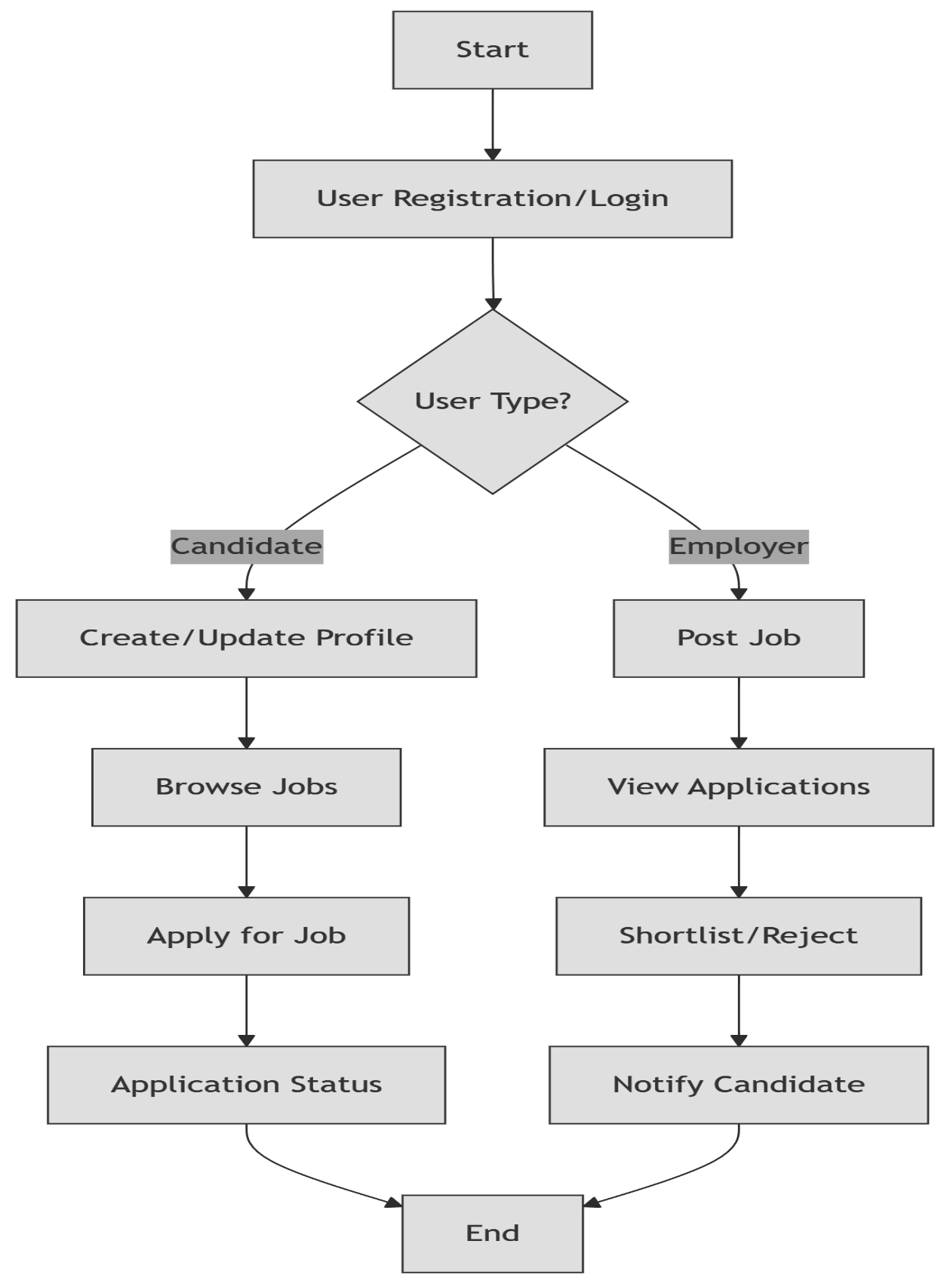

Algorithm

The pseudocode below outlines the logic for the job application process. It includes user authentication, profile validation, and database operations to ensure only eligible candidates can apply for active job postings.

1. BEGIN SYSTEM INITIALIZATION
2. Load Django settings (settings.py)
3. Establish MySQL connection (DATABASES config)
4. Migrate models (python manage.py migrate)
5. END INITIALIZATION

6. WHILE system_running DO
7. Display homepage with [Login/Register] options
8. GET user_input (role selection: Candidate/Employer)

9. CASE user_input OF
10. "Candidate":
11. IF new_user THEN
12. CALL registration_module()
13. ELSE
14. CALL login_module()
15. IF login_success THEN
16. DISPLAY candidate_dashboard
17. CALL profile_management()
18. CALL job_search_module()
19. END IF
20. END IF

21. "Employer":
22. IF new_user THEN
23. CALL registration_module()
24. ELSE
25. CALL login_module()
26. IF login_success THEN
27. DISPLAY employer_dashboard
28. CALL post_job_module()
29. CALL view_applications()
30. END IF
31. END IF
32. END CASE

33. FUNCTION registration_module()
34. GET (username, email, password, role)
35. VALIDATE inputs (Django forms)
36. IF valid THEN
37. INSERT INTO auth_user (MySQL)
38. SEND confirmation_email
39. RETURN success
40. ELSE
41. RETURN validation_errors
42. END IF

43. FUNCTION login_module()
44. GET (username/email, password)
45. AUTHENTICATE (Django auth)
46. IF credentials_valid THEN
47. START session
48. RETURN dashboard_redirect
49. ELSE
50. RETURN error_message
51. END IF

52. FUNCTION job_search_module()
53. QUERY jobs WHERE (deadline >= NOW() AND status=ACTIVE)
54. DISPLAY paginated_results (20 jobs/page)
55. IF candidate_applies THEN
56. INSERT INTO applications (job_id, candidate_id, status=PENDING)
57. TRIGGER application_notification()
58. END IF

59. FUNCTION post_job_module()
60. GET (title, description, salary, deadline)
61. VALIDATE employer_permissions
62. IF valid THEN
63. INSERT INTO jobs (employer_id, ...)
64. RETURN job_preview
65. END IF

66. FUNCTION view_applications()
67. QUERY applications WHERE (job_id IN employer_jobs)
68. DISPLAY with [Shortlist/Reject] buttons
69. IF action_taken THEN
70. UPDATE application_status
71. TRIGGER status_email_to_candidate
72. END IF

73. END WHILE
74. ON system_exit: CLOSE DB connections

Visual Workflow

This sequence diagram demonstrates the data flow when a candidate submits a job application. The workflow spans user input, backend processing in Django, and MySQL database operations, culminating in a user confirmation.

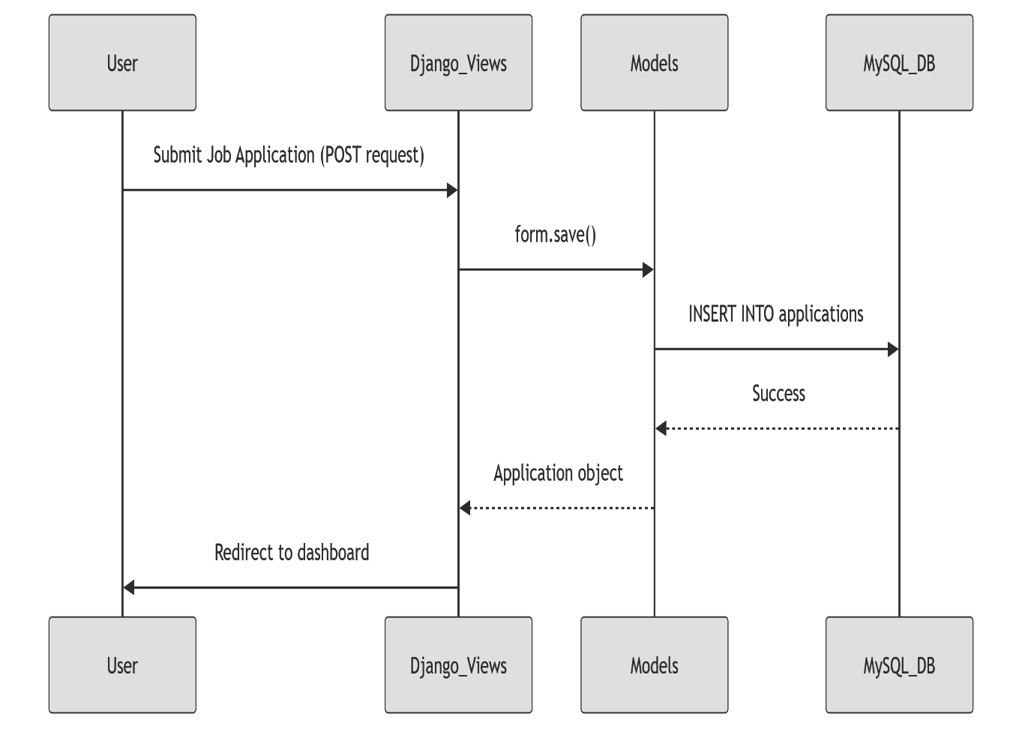

Sample Outputs
Login Page
The unified login page allows users to authenticate as Candidate, Employer, Admin using secure Django authentication. Field validation and feedback messages ensure user-friendly error handling.
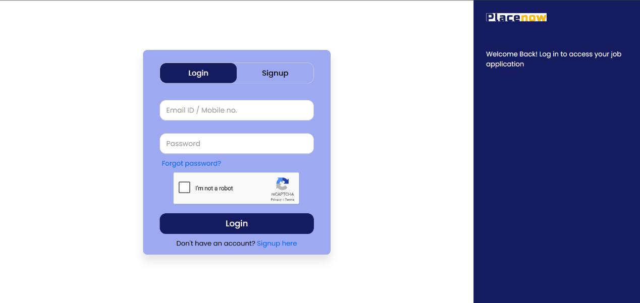

Sign Up page
The registration page allows users to create an account by selecting their role as an candidate or Employer. Each role is associated with a different profile structure and dashboard. Form validation ensures that inputs such as email, username, and password meet security and format requirements.
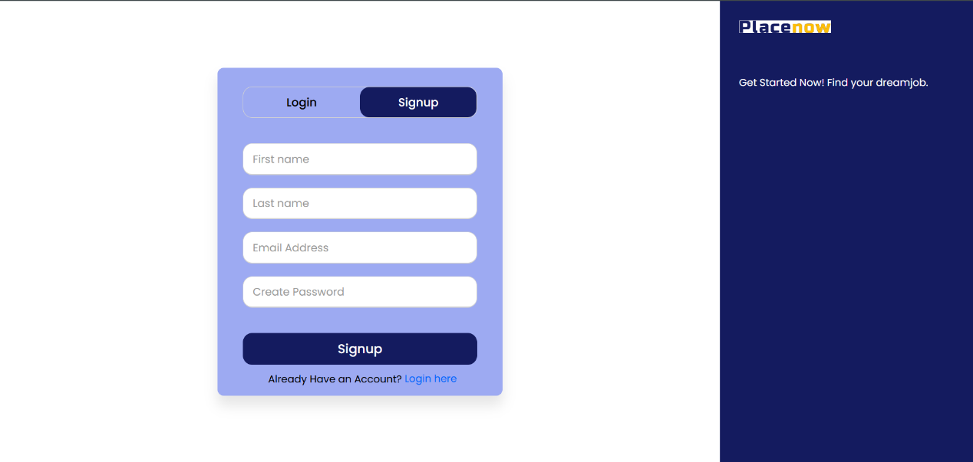
Job search page
Once logged in, influencers can access a job search module that allows them to browse active postings. Jobs can be filtered based on criteria such as location, niche, role, or deadline. The search functionality is dynamically powered through Django ORM queries.
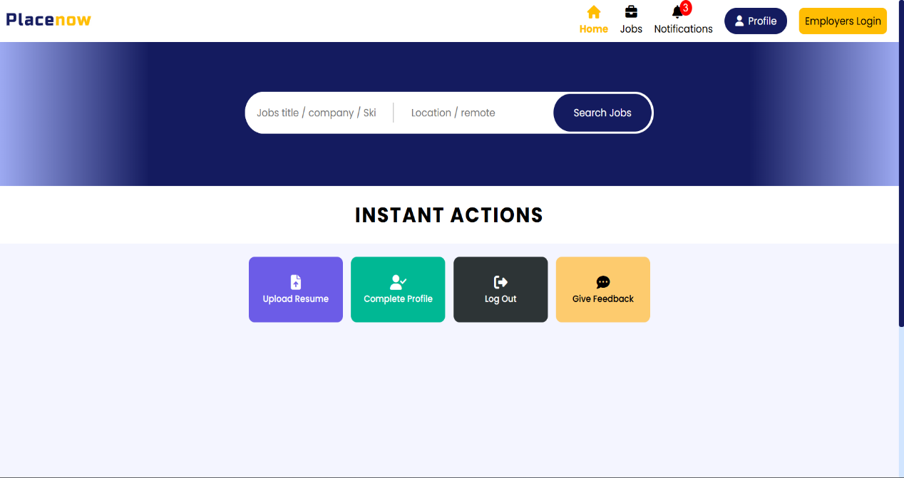
Job search result page
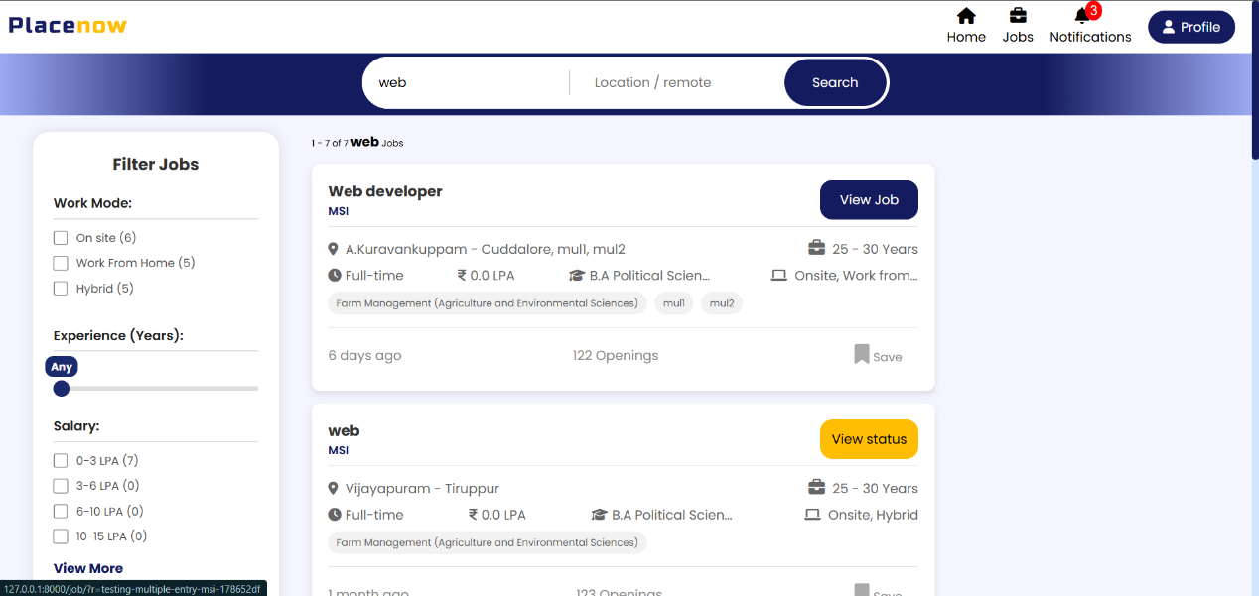
Upon applying filters or submitting a search, the platform displays a list of relevant job results. Each job card includes key information like job title, budget, deadline, and a button to view more details or apply. The design is mobile-responsive and easy to navigate.

Profile page
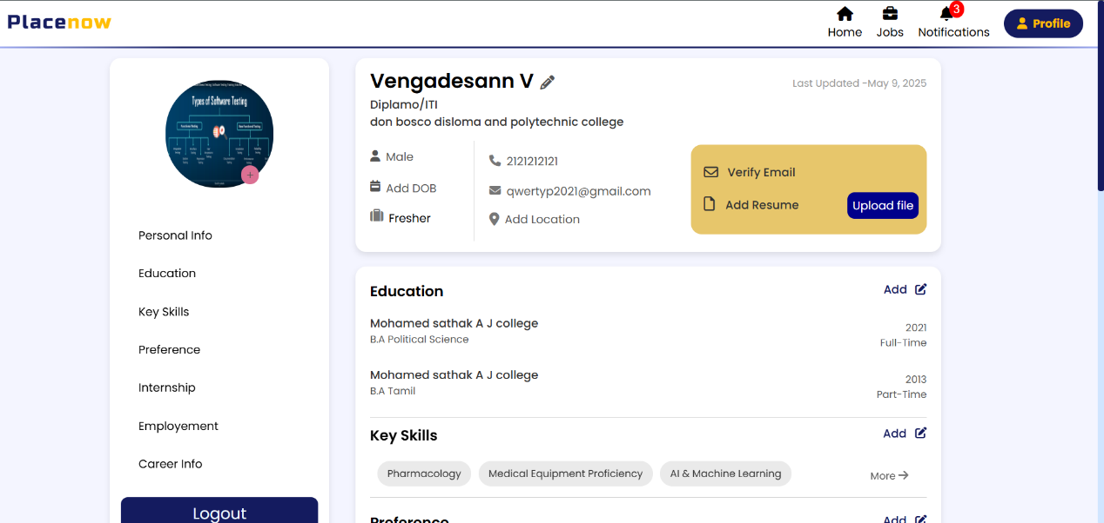
Candidate can manage their personal details and update their education and experience and personal data and bio. A profile completion indicator is also available to guide users in submitting all necessary information. Only complete profiles are allowed to apply for jobs.

View Status of Job
After applying for jobs, candidate can view the status of each application directly from their dashboard. The status options include Applied, Shortlisted, Rejected, and Hired. This feature helps users track their progress and stay updated on employer decisions.

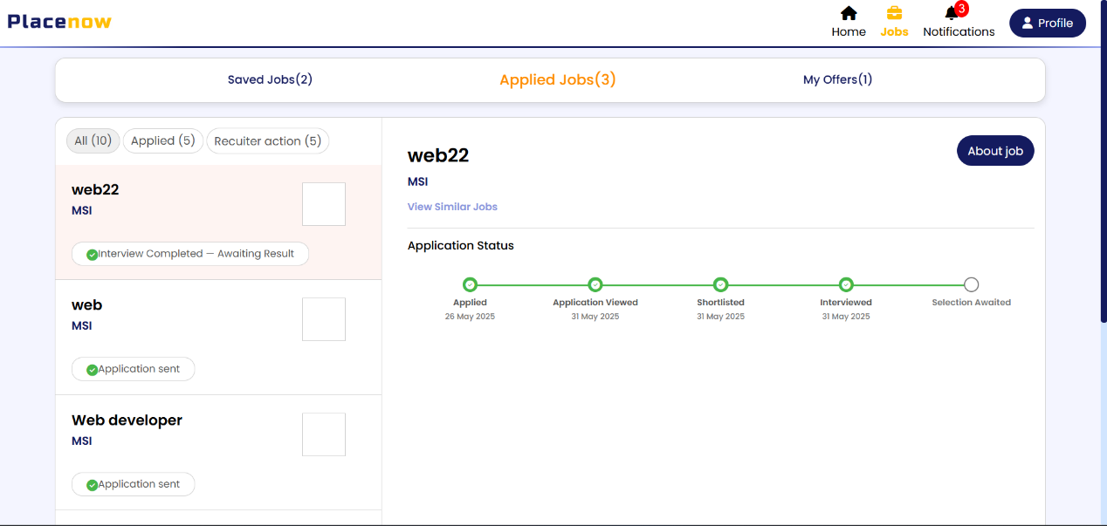

Job Description
When an candidate clicks on any job listing, they are redirected to a detailed Job Description page. This page includes all relevant information posted by the brand, such as:
- Job Title and Role
- Budget/Payment Range
- Required Niche or Skills
- Job Description / Scope of Work
- Location (if applicable)
- Application Deadline
- Company Name or Contact Info
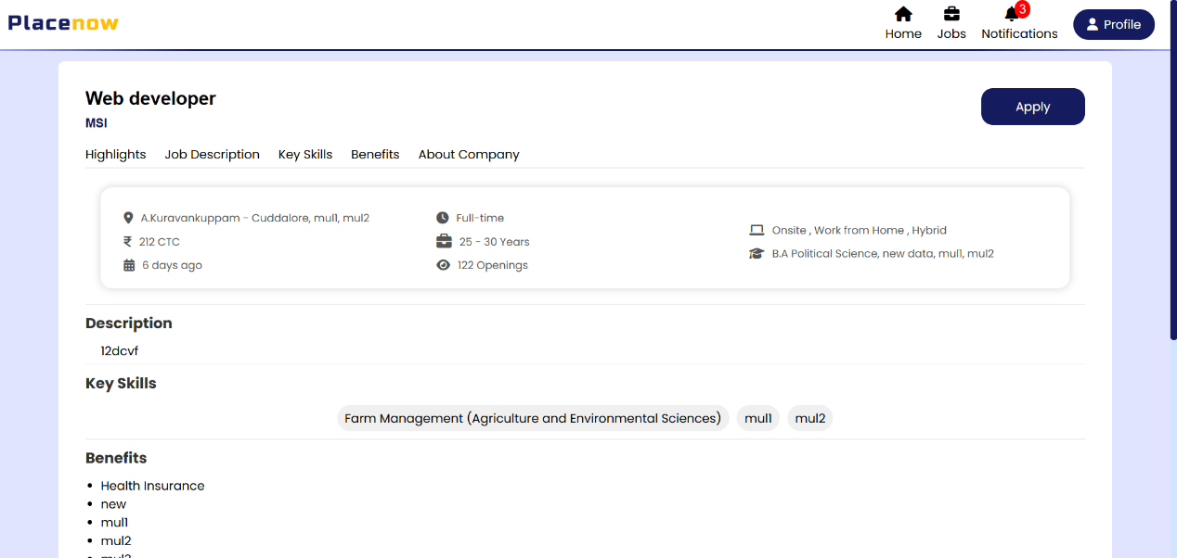

Job post creation (Employer)
Employer can post jobs using a structured form that captures title, description, budget, and deadline.
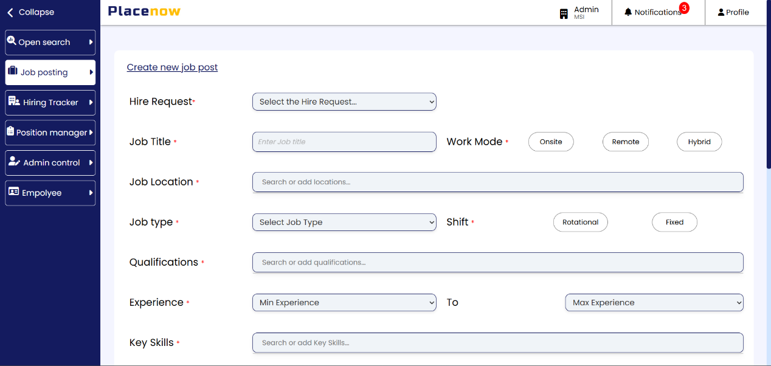

View Applicants
All posted jobs are listed on the Employer dashboard. Each entry includes a quick overview of the job, number of applicants, and a button to view or edit the job. Employers can also shortlist or reject applicants from this section.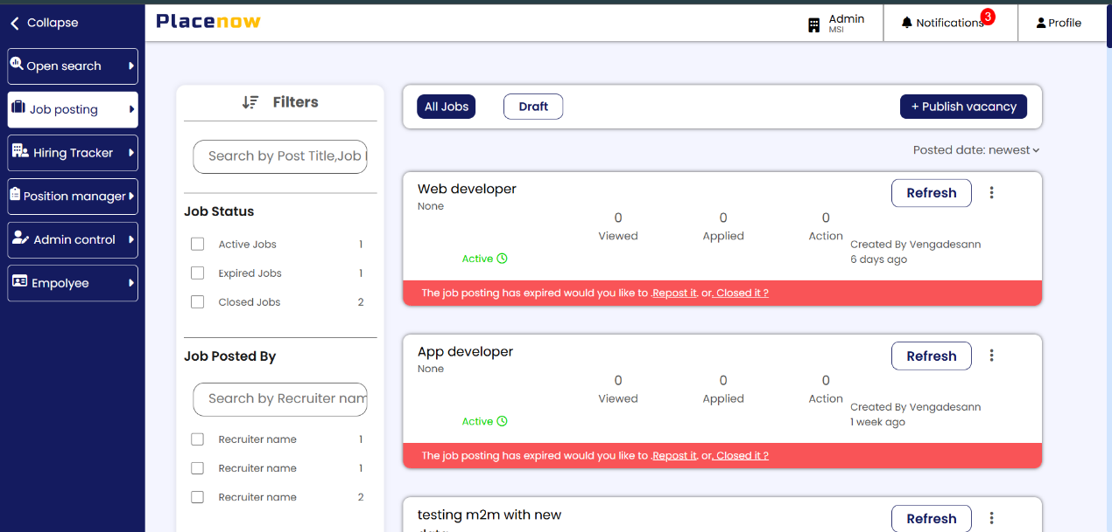

Outcome of the Training

The six-month internship at SkillHabitats Workforce Solutions Pvt. Ltd., focused on the development of the PlaceNow hiring platform, provided valuable hands-on experience in full-stack web development, project planning, and real-world deployment practices. The internship offered a blend of technical challenges and professional responsibilities, leading to both skill enhancement and personal growth.
Throughout the training period, I significantly deepened my understanding of backend development using Django, including model creation, user authentication, form handling, and custom business logic implementation. I also worked extensively with MySQL, writing efficient queries, managing relationships between models, and optimizing database performance for real-time search and filtering operations.
On the frontend, I applied my knowledge of HTML, CSS, and JavaScript to design responsive and user-friendly interfaces. This included building multi-role login systems, dynamic dashboards, job listing pages, and structured forms for both influencers and brand users. Special focus was given to cross-browser compatibility and clean UI layout to enhance user experience.
Additionally, the deployment process taught me how to manage cloud-based hosting environments using an Ubuntu server on AWS EC2, including server configuration, security practices, and application uptime monitoring. I also gained exposure to version control through Git, and developed a basic understanding of performance optimization and production-readiness.
This internship helped me strengthen my communication, problem-solving, and time management skills while working under real deadlines. Collaborating with project mentors and handling project modules independently provided a real-world preview of the software development lifecycle in a professional setting.
Overall, the training was a transformative experience that bridged the gap between theoretical knowledge and practical application. The outcomes achieved during this internship have laid a strong foundation for my career as a full-stack web developer and improved my confidence to work on live client-based projects.

Conclusion

The internship at SkillHabitats Workforce Solutions Pvt. Ltd. has been a pivotal experience in my academic and professional journey. As a Full-Stack Development Intern, I had the opportunity to work on a live, industry-ready hiring platform (PlaceNow), which gave me deep insight into real-world software development and deployment practices.
Throughout the six-month period (December 1, 2024 – May 31, 2025), I was actively involved in building and refining both backend and frontend features using Django, MySQL, HTML, CSS, and JavaScript. The project demanded structured coding, performance-aware database management, and clean UI development—skills I now feel confident applying to future roles in software development.
Working in a production-level environment taught me how to integrate technologies, handle user roles, manage data security, and deploy using Ubuntu servers on AWS. These experiences not only strengthened my technical foundation but also helped me appreciate the importance of testing, modular design, and scalability in web applications.
Beyond technical growth, the internship helped shape my soft skills as well. I improved my time management, task prioritization, and communication—especially when collaborating with mentors and reporting weekly updates. Being part of a project preparing to go live gave me a sense of real responsibility and accountability.
This experience has been more than just a learning opportunity—it has equipped me with the tools, mindset, and confidence to take on larger development roles in the future. I now feel well-prepared to contribute to full-scale applications in a professional setting.

